February 19th, 2012
Hi

I will start with the ongoing saga known as the Chief Executive elections, which is now turning into a soap opera or a comedy, farce or tragedy, depending on how you look at it. Henry Tang, the former Chief Secretary (#2 in the government hierarchy) and the person Beijing wants to win, has been getting into trouble with illegal building works at one of his two adjacent low-rise houses in Kowloon Tong. It has been revealed that during, or maybe after, the houses were built, one of them has a 2300 sq ft illegal basement. And not just any basement. It is fitted out with a cinema, a gym, a wine cellar and a jacuzzi. The trouble began when he denied there was any basement. Then the press found out there was a basement and even printed a plan of it. A few days later, he blamed his wife for the illegal construction! By this stage, the whole of HK was engrossed with the drama unfolding daily. So much so, that media organisations hired cranes to be hoisted, with their cameras, above the houses. There were 10 to 12 of these cranes (see picture). He also denied other things about his houses. One was that the two houses were separate structures and not joined (which is also illegal), until a media video clip showed the family pet dog having no trouble walking from one house to the other. All this is rather hilarious - if it weren't so serious. There have been calls for him to pull out of the race but he refuses to do so. There appears to be a lot of panic in “pro-Beijing” circles over these problems with their preferred candidate. Another pro-government person, who would be acceptable, has been begged to run. Then yesterday, Henry Tang was 'summoned' to the local Beijing office, though what transpired has not been revealed, though it is not difficult to guess what the subject was. And last night on the news, the latest popularity ratings of the three current hopefuls was broadcast, with Tang's rating, already on the way down, down further to about 21%, while that of his main rival is up to 49%. The week's events have also gone international, with a report on the Aus TV news. Stay posted, as doubtless more will happen this coming week.
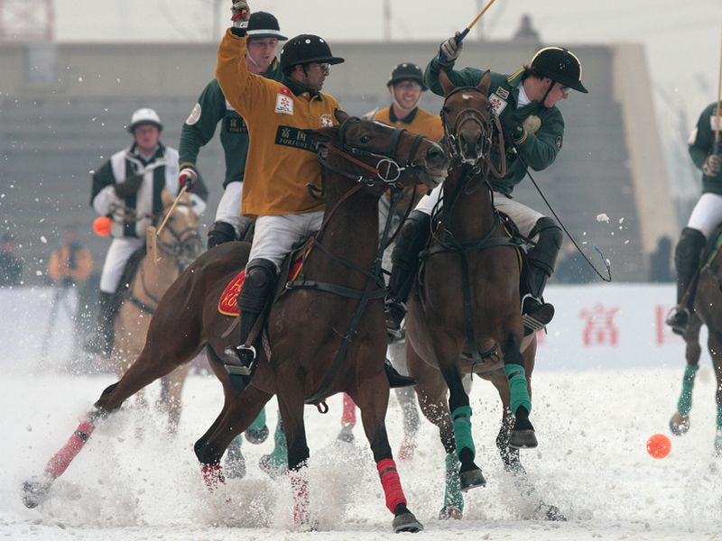
Last Sunday, HK won an international snow polo tournament in Tianjin in northern China, beating South Africa in the final (picture, HK in yellow shirts). All the team members were expatriates. In Las Vegan, Samoa beat NZ 26-19 in the final to claim the USA Sevens title. I read on the Planet Rugby website that Jonah Lomu will need a second kidney transplant as his health continues to deteriorate.
In HK, a mainland woman was given 10 months jail for breaching immigration regulations in helping pregnant women to come to HK to give birth. Other convictions will probably follow. The Bank of China (BOC) is celebrating its centenary by issuing special banknotes. There was chaos outside BOC banks on several days as thousands of people, many of them mainlanders, queued to get the banknotes. The other morning at 2.30 am, a 4.8 earthquake was felt by some in HK; its epicentre was somewhere is Guangdung about 100 km from here. The feeling from a 4.8 quake is similar to that produced by a heavy truck on a road.

More anniversaries this week. Last Wednesday, February 15th, was the 70th anniversary of the fall of Singapore to the Japanese. And today, the 19th, the Japanese bombed Darwin. Right at this moment there are commemorations of the event taking place in Darwin. And tomorrow, the 20th, is the 50th anniversary of the first flight of a US manned space vehicle to orbit the Earth (somewhat after that achieved by the Russians). It is manned by John Glenn (who was Marine) in his Mercury spacecraft.

The run yesterday was better than expected - from Tai Po to the Shing Mun reservoir, up the appropriately-named Needle Hill and back. Took 2 h 48 min, a few minutes faster than last year!! Quite cool. At the top of Needle Hill, a group of people asked me to take a photo. They gave me a camera that looked like a cassette tape (see right). I did not know how to work it. First, I pointed the screen/viewer towards them. Then they said 'the other way round' so I turned it vertically, then they had to show me that I should be looking at the screen! Oh dear - I am losing touch with all this modern technology! (I have just discovered from online that the cassette part is actually a protective cover for a mobile phone.) (And, by the way, I remembered to note from my watch how long all this took, and adjusted the time for my run accordingly.)
The 'problem' with my Drive C continues to puzzle. This is how the storage has changed in the past week or so: 11.3 GB → 12.2 → 11.3 → 12.1 → 11.8, which is what it is now. I searched online and found that many people have a similar problem with the storage space being use up, though I found no-one with the storage going both up and down as in my case.
For you medical people, a little in the latest Time on factors affecting loss of memory. Turns out that memory loss is hastened in people who overeat and also in those who don't sleep well (waking up more than five times each hour). One more reason to ban buffet meals, which tend to encourage overeating as well as leading to an appalling waste of food (though I do admit I don't mind the occasional buffet myself, which usually happens when I am visiting places with the Singapore publishers).
That’s about it.
Cheers.
---------------------------------------------------------------------------------------------------------------
February 20th, 2011
Hi
There is not much to write about so I will leave some interesting bits from last year's letter, which I over-writing.
My cousin Roger and his wife Maureen arrived on Thursday early evening. They flew with Cathay Pacific. I had given them instructions on how to get the hotel shuttle bus from the airport to here. I had also e-mailed them about getting Octopus cards at the airport, which they did. We went to the shopping mall next door and had dinner at “Fairwood” (a fast food restaurant). It is the first time I have been there and the food was not too bad. However, there was a bit of a problem with ordering the dishes we wanted. On a wall each dish on offer, together with a photo of the dish and its price is displayed on a plastic plaque (about 1 foot by 4 inches). But there is no identifying number on them that you can tell the cashier what you want. So, what did I do? I took the three plaques off their hooks and carried them over to the cashier! Quite effective really. They slept on the fold-out sofa. The temperature on their arrival was about 12⁰C and it was very misty. We have been having a lot of that sort of weather recently and it is even worse today with mist/low cloud and some drizzle.
On Friday, they got up when I did and later went into TST to meet friends of theirs, also from NZ, who were staying at a hotel there (but who had flown with Air NZ). They spent the day together and got back at about midnight, having become lost around here by failing to get off at the third stop from the main railway station! They ended up doing a grand loop of Tin Shui Wai.
Today was cool, misty and damp for the run with the temperature constant at about 11⁰C. because of all the work I have to do and because of guests being here, I did a shorter run so that I would not be too tired. It was a good run, but just 2 h 09 min, exactly as I had predicted, based on the records I keep of my runs.
R and M here after I had left and will again spent the day with their friends. They leave HK on Tuesday and fly to London, where they stay just overnight and then fly back to Istanbul (Turkey), where their friends will already be. After a few days there, they go to Italy and from there back to the UK (I think).
I forgot to mention that last weekend, the fourth leg of the World 7s was held in Las Vegas. SA won. The next round will be the HK 7s late in March.
The HK Marathon was completed earlier this morning. They has three races – the full marathon, a half marathon and a 10 km race. There were 65 000 participants in the three races. The first two places in the main race went to runners from Kenya.
From last year's letter
We have had a cold (for HK), drizzly week. Temperatures went down to about 7⁰C. However, they were still not cold enough for ice to form on the top of Tai Mo Shan, which does not seem to happen so often now.
Last weekend, the latest round of the IRB 7s was held, for the first time, in Las Vegas. Samoa beat NZ in the final.
I received an interesting ‘monthly report’ from Norton Internet Security. There 2010 version is much better than those of previous years, and provides a lot more information and checks (even right this minute a ‘Norton PC Checkup’ – not a scan - just began automatically). Well, the report gives an interesting way to fool hackers when entering passwords, etc. The problem is due to hackers who get into your computer and keep track of every keystroke you make. So when you type in your passwords, credit card numbers, etc, the hackers have a record of these. I quote:
“You can also keep hackers from finding what they're looking for; passwords and credit card numbers you enter at e-commerce sites. There is software that stores passwords and credit-card numbers and enters them automatically. Or, take advantage of the fact that keystroke loggers don't track your mouse. For instance, enter the first three letters of your password, then enter three incorrect letters, then use your mouse to select those and type the correct ones over them (without pressing "delete"). This causes your password to appear three characters longer than it really is.”
An example: Suppose your password is 123456.
1. Type in the first 2 or 3 number then some false numbers, e.g. 123958.
2. Select the false numbers with the mouse: 123958
3. Do not press the delete key as that is a keystroke and the numbers will be deleted on the hacker’s screen. Instead just over-type in the remaining password numbers, i.e. 456.
4. So what you have entered is 123456. But what the hacker sees is 123958456.
NB: Of course, when you enter passwords, dots appear on your screen. But the numbers are underneath and the hacker picks these up.
There was an interesting TV report on credit and debit card traps in the US (and of course elsewhere as well). The trap is the very high interest rates charged when you are over your limit or do not pay your debt on time. I also found this out when I first used my credit card and realised that the credit limit is really a false limit. This is because the previous month’s credit is not due to be paid until several weeks into the next month and still shows on the account. Thus, if the monthly limit is $2000 and you spend $1200 this month, your spending limit for most of the next month is only $800 and not the full $2000. So if you go over the $800, you are charged high interest. While the programme was talking about credit cards, I was thinking that it would be better to pay with a debit card. But then they got onto debit card traps. Apparently, if you spend more than is in your account, banks will allow you an overdraft at very high interest rates charged weekly. An example was given of a woman who overspent by $7 when she bought a pizza and was charged $33 for each week it was not repaid. A $33 charge is about 470% for a week and 5657% for a year. Another person who had an debit-card overdraft was charged at an annual rate of 24000%!!! So beware – always check that you have enough to pay for what you purchase and do not get into debt, as this is how the banks make there their money. If you do not go into debt and always pay on time, charges are zero. My policy has always been never to go into debt; if you cannot pay for something, do not buy it. The only exemption might be a house mortgage but even then, the value of the house should cover the mortgage unless you go into ‘negative equity’, i.e. the value of the house drops and is less than the value of the mortgage. (In HK, many people think they are in negative equity if the value of the house/flat drops but this is not correct. It is only if the property value drops below the mortgage value and so the mortgage cannot be paid off by selling the house. (A person who has no mortgage has no negative equity no matter how much the value of the property drops.)
There was an article in the SCMP on how babies are more likely to be bilingual if they hear two languages in the womb and how experiments on newborn babies seemed to confirm this. For the full study, refer to the article published this week in the journal Psychological Science (though it does not yet seem to be online).
Picked up “Prisoner of the State” (based on the diaries of Zhao Ziyang, the Chinese Premier who was sympathetic towards the protesting Tienanmen students in 1989, and who consequently lost his job and standing) the other day and am reading it now. Very interesting to learn what was going on at the top levels prior to and during the 1989 student crackdown in Beijing.
That’s about all for this time.
Cheers.

